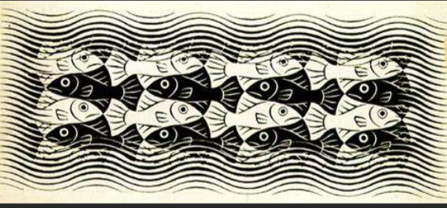

Picture by MC Escher who used tessellation to form his pictures.
Can you spot the black fish swimming on way and white the other? There are no gaps!

